**Module (JQuery Basic, Effects & Advanced) – 5**

1. **What is jQuery?**

**Ans.** JQuery is a fast, small, and feature-rich JavaScript library. It makes things like HTML document traversal and manipulation, event handling, animation, and Ajax much simpler with an easy-to-use API that works across a multitude of browsers. With a combination of versatility and extensibility, jQuery has changed the way that millions of people write JavaScript.

Basic syntax is: $(selector).action() A $ sign to define/access jQuery. A (selector) to "query (or find)" HTML elements. A jQuery action() to be performed on the element(s)

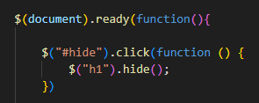

1. **How to Apply CSS Using JQuery, How to Add Class and Remove Class in Jquery , JQuery Animation?**

**Ans.** In jQuery, we can apply CSS styles to HTML elements using the **.css()** method. This method allows you to set or get the value of one or more CSS properties for a selected set of elements. Here's a basic example of how to apply CSS using jQuery:

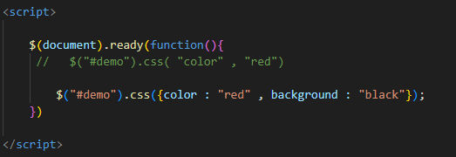

We can also use the **.addClass()** and **.removeClass()** methods to add or remove CSS classes from elements. This is often preferred when you have multiple CSS styles to apply or when you want to manage styles separately from your JavaScript code.

$(selector).addClass(className);

$(selector).removeClass(className);

**JQuery Animation**

JQuery provides a simple yet powerful way to create animations on web pages. The **animate()** method is used to perform custom animations of a set of CSS properties. example:

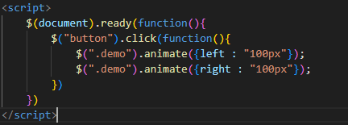

1. **How to create slider with animation?**

**Ans.** With jQuery you can create a sliding effect on elements.jQuery has the following slide methods:

* The jQuery slideUp() method is used to slide up an element.

slideUp()

* The jQuery slideDown() method is used to slide down an element.

slideDown()

* The jQuery slideToggle() method toggles between the slideDown() and slideUp() methods.

slideToggle()

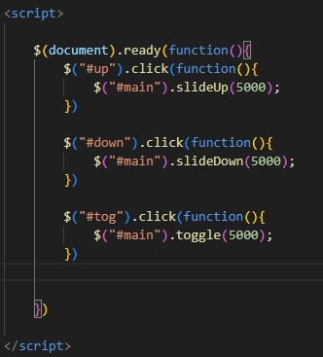

1. **Event bubbling tickling example**

**Ans.**

